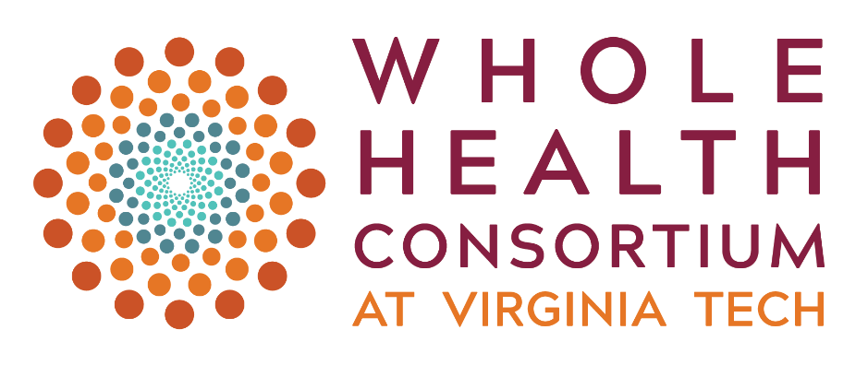

Request for Proposals (RFP)

**Required Letter of Intent Due September 13, 2024**

***Overview***

The **Whole Health Consortium (WHC) at Virginia Tech** is pleased to announce its annual funding opportunity that aligns with our overarching goal of investigating **equitable health and well-being solutions that support people and their communities to pursue meaningful lives**.

The WHC aspires to lead a paradigm shift toward a whole-health approach to well-being by addressing health integrated across levels—from molecular, behavioral, social, environmental, and societal—and prioritize a proactive model of disease prevention and well-being of individuals and communities. This vision is rooted in a commitment to advancing transdisciplinary research and calls on expertise across and beyond the university to inform equitable solutions for holistic health and well-being.

We aim to assemble collaborative multidisciplinary teams comprised of researchers and community partners who would be uniquely positioned to compete for external funding opportunities such as NIH Program Projects (P Series), Center Grants (U and P Series), NSF Growing Convergence Research (GCR) Grants, and Patient-Centered Outcomes Research Institute (PCORI) Grants, among other significant grants focused on tackling health and well-being in transformative ways (see Appendix A for examples).

Our Request for Proposals (RFP) serves as an initial step toward building momentum and creating a compelling research portfolio. We are granting awards that will enable researchers to form collaborative and interdisciplinary teams to study whole health from a multilevel and integrative perspective. The goal is to prime these teams for high-impact, community-engaged research, setting the stage for them to develop robust research proposals to successfully compete for larger, more substantial grants.

**Priority Funding Areas**

This year, in addition to our continuing emphasis on **mental health**, we invite proposals that explore topics that address the interconnected dimensions of physical, emotional, and social health throughout daily life and across the lifespan. We encourage preliminary **investigations of** **health on multiple levels**, ranging from molecular and cellular mechanisms to individual behaviors and lifestyles to social determinants, cultural influences, and physical/environmental factors.

Our community partners have identified key priorities, including addressing overmedication, substance use, and the development of trauma-informed communities. In support of these priorities, we invite research focused on the prevention and management of chronic diseases and co-occurring conditions through pilot studies of **multi-component interventions** (must evaluate each component separately as well as together to determine which elements contributes most effectively to clinical outcomes).

Research exploring how[**social drivers of health**](https://health.gov/healthypeople/priority-areas/social-determinants-health) contribute to disparities in health outcomes and access to care is of high priority. In this regard, we encourage proposals that address **health disparities and promote equity**, particularly in underserved populations and those affected by adverse environments (e.g., polluted areas, climate-vulnerable, high-crime neighborhoods, substandard housing, food deserts, hazardous workplaces, inadequate healthcare access, marginalized and discriminatory environments). We also welcome research that identifies barriers and facilitators to building **trauma-informed communities** across various sectors—including health care, education, public safety, faith-based organizations, workplaces, and community groups.

Impactful community-engaged research is foundational to the Whole Health Consortium; therefore, proposals must include community partners as actively engaged participants in the research and are encouraged to meaningfully integrate individuals with lived experiences into their research.

The Consortium will offer awards in two funding tracks: Track I: *Advancing Partnerships* and Track II: *Incubating Emergent Collaborations*.

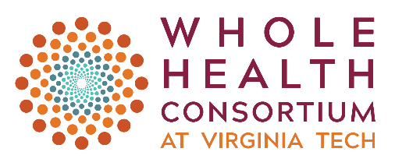

***Track I: Advancing Partnerships***

Award Amount: Up to $40,000 per award

Duration: 12 months

Number of Awards: 2 to 3

**Objective**

Given the complexity and multidimensional facets of health and well-being, addressing it from a holistic perspective requires a focused and synergistic effort from research teams. The primary objective of this planning grant, called *Advancing Partnerships*, is to catalyze multidisciplinary research teams in advancing whole health research. Teams applying for this grant are expected to assemble 3-5 interconnected projects (see Appendix A for examples). Each project should have its own unique objectives and also contribute collectively to a common thematic goal in a specific area of whole health research. The *Advancing Partnerships* grant serves as a foundational step in two ways: first, by positioning each project within the team for successful application for additional funding from a government agency, foundation, or corporate sponsors. Specifically, teams are expected to submit individual proposals addressing each project component or joint proposals integrating two or more project areas within twelve months of completing the *Advancing Partnership* grant, each targeting a minimum of $200,000 in direct costs per year. Second, the grant also intends to cultivate evidence of effective collaboration through means such as joint publications or other forms of collaborative scholarly output.

**Strategic Intent**

The *Advancing Partnerships* grant is an integral part of the Whole Health Consortium’s long-term strategy expected to unfold over a period of five years. The intent is to foster research teams that are competitive for NIH Program Projects (P Series) and Center Grants (U and P Series), or other such significant grant opportunities, in line with our focus on holistic health and well-being (see Appendix A for examples). These teams should articulate a unified and impactful research agenda and demonstrate sustainable research partnerships among team members. Furthermore, they should effectively manage an interconnected network of research projects that share knowledge and resources and maintain consistent engagement with community partners.

**Eligibility**

Multidisciplinary teams comprising researchers from **three or more disciplines** with complementary skills and expertise are encouraged to apply. The lead Principal Investigator/s (PI) should be full-time, tenure-track/tenured faculty member, a Research Professor, Research Scientist, or a [faculty member with PI status approved by Senior VP for Research and Innovation](https://www.research.vt.edu/osp/resources/principal-investigators.html) at [Virginia Tech](https://www.vt.edu/academics/depts-colleges.html).

Team members may include research faculty, collegiate faculty, clinical faculty, or professors of practice. Please check the eligibility chart (Appendix B) for exceptions. Teams are required to partner with community organizations and/or not-for-profit healthcare entities. Applications demonstrating robust, active engagement with the community organizations will be prioritized for funding. Please refer to the Eligibility Requirements before submitting your application (Appendix B).

All team members should be existing members of the Whole Health Consortium; submission of the application for membership is required prior to submitting full (invited) applications.

**Key Dates**

* 2-page Letter of Intent due on September 13, 2024 (by noon)
* Notice of invitation to submit full proposal received by September 24, 2024
* Full (invited) Applications due on November 18, 2024 (by noon)
* Notification of Awards: December 17, 2024
* Funding Period will run from January 16, 2025 to December 31, 2025

**Application Process**

**2-Page Letter of Intent (LOI)** should include:

1. A brief description of the proposed multidisciplinary team project outlining the 3-5 interconnected projects that the team will focus on in their application. Clearly delineate how the planning grant work will directly contribute to both community-collaborative research in whole health and align with the team’s broader research objectives. The LOI should also outline plans for securing future funding to sustain these initiatives.
2. Include the names, titles, affiliations of the PIs and key team members; as well as the community organizations or not-for-profit healthcare entities with which the team will partner.

Successful LOIs will be invited to submit a full proposal.

**Invited Proposals** must include:

1. E-signed Coversheet (available at [https://wholehealth.isce.vt.edu](https://wholehealth.isce.vt.edu/)/)
2. 250-word abstract describing the research topic/team project in language suitable for the general public and posting on the Whole Health Consortium website
3. Team Project Narrative of **up** **to four** pages which includes:
   1. *Research Team’s Overall Goals*: Provide an overview of your research team’s collective objectives. Explain how your proposed projects cohesively address a specific theme or issue within the field of whole health (1 paragraph).
   2. *Individual Projects*: Describe 3 to 5 individual projects (1 paragraph for each project) that contribute to the overall research goal. For each project, succinctly specify its significance, specific aims, methods and anticipated outcomes.
   3. *Community Partnership*: Detail the relevance and role of community partnerships in your research endeavors (1 paragraph).
   4. *Use of Planning Grant Funds* (up to 2 pages):
      1. Explicitly outline how the planning grant will further your team’s research agenda in the context of whole health. For each activity (e.g., piloting projects, developing collaborations, collecting preliminary data, performing feasibility studies), provide a justification for the activity in relation to the research objectives, the steps to be taken to accomplish this activity, the key personnel involved and their role, and how success will be measured or evaluated.
      2. Identify any potential challenges that could impede the successful implementation of your planned activities and your contingency plans for addressing these challenges.
4. Timeline and Key Milestones: Present a clear timeline for the use of grant funds, detailing when each activity outlined in the Project Narrative will take place. Include key milestones that serve as indicators of progress, directly linked to the planned activities and overall project goals.
5. Itemized budget sheet and budget justification.
   1. Applicants must divide their budget submissions into two segments. The first segment should cover expenses for January 16, 2025 through June 30, 2025, while the second segment should outline expenses for the period of July 1, 2025 through December 31, 2025.
   2. Budget justification should include how the grant funds will be used to support the planned activities.
6. Primary team members, including identification of the team leader/s, primary role of each team member on the project, and a brief description of the expertise of all team members, consultants, and the community partner/health entities as it relates to the proposed study (do not submit curriculum vitae; 2 pages max). Each team member should be a WHC’s active member at the time of application.
7. Appendix (1 page max) which includes:
   1. Information about specific funding mechanisms the team will pursue in the short term.
   2. Team’s vision for center-scale or program project-scale proposal, highlighting the team’s expertise and competitiveness, planned proposal-building and team-building activities envisioned, and an anticipated timeline to submission.

**Expectations and Outcomes**

Each team selected to receive the *Advancing Partnerships* grant is required to:

1. Acknowledge the Whole Heath Consortium support in all media interviews, presentations, or publications related to the award.
2. Present team’s findings at forums or other events sponsored by the Whole Health Consortium, as requested.
3. Submit a progress report, including a fiscal report documenting use of funds, by June 30, 2025.
4. Provide a comprehensive final report within 30 days of the project end date. This should include a summary detailing the team’s collaborative activities like joint publications and other forms of scholarly output that demonstrate effective collaboration, next steps, and a final fiscal report. This should be submitted by January 31, 2026.
5. Submit annual progress reports for three years after the award end date (specific due dates/reminders will be sent).
6. Develop and submit individual proposals addressing each project component or joint proposals integrating two or more project areas for funding consideration to a government agency, private organization, corporation, or foundation, no later than December 31, 2026. Exceptions may be considered based on the due dates of individual agencies and foundations.
   * Submit the proposal cover page and abstract to the Whole Health Consortium upon submission of the proposals to the external funding source.

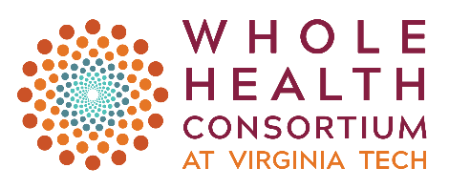 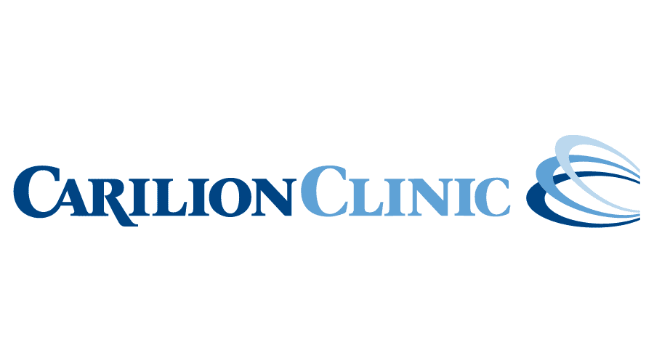

***Track II: Incubating Emergent Collaborations***

**Important Note:** Funding for this track is generously provided in collaboration with Carilion Clinic.

Award Amount: Up to $10,000 per award

Duration: 6 months

Number of Awards: 4 to 6

**Objective**

The primary goal of this Incubator Grant is to support small-scale, high-impact projects that bring together scholars from at least two different disciplines and involves a community partner. This grant is designed to enable researchers and organizations to develop preliminary data, proof of concept, or initial prototypes with the potential to evolve into larger initiatives eligible for substantial long-term funding. Deliverable may be in the form of mini-pilot or feasibility studies, rapid needs assessment, initial stakeholder engagement and community outreach activities, and initial grant proposal drafting. The project should align with the broader mission of advancing evidence-based research in whole health, with the long-term vision of seeking larger grants and forming a more extensive multidisciplinary team as a long-term goal.

**Strategic Intent**

The Incubator Grant serves as an initiation phase for long-term research agendas. The intention of the grant is to "incubate" innovative ideas to the point where the team can successfully compete for larger, more sustainable grants and collaborations in the future. Incubator grant awardees are expected to seek funding from a government agency, foundation, or corporate sponsors, targeting a minimum of $100,000 in direct costs per year, within six months of completing the Incubator Grant.

**Eligibility Criteria**

The proposed project should involve at least **two disciplines**. The lead Principal Investigator/s (PI) should be full-time, tenure-track/tenured faculty member, a Research Professor, Research Scientist, or a [faculty member with PI status approved by Senior VP for Research and Innovation](https://www.research.vt.edu/osp/resources/principal-investigators.html) at [Virginia Tech](https://www.vt.edu/academics/depts-colleges.html). Team members may include research faculty, collegiate faculty, clinical faculty, or professors of practice. Teams are required to partner with community organizations and/or not-for-profit healthcare entities. Applications demonstrating robust, active engagement with the community organizations will be prioritized for funding. Please check eligibility requirements before applying (see Appendix B).

All team members should be existing members of the Whole Health Consortium; submission of the application for membership is required prior to submitting full (invited) applications.

**Key Dates**

* 2-page Letter of Intent due on September 13, 2024 (noon)
* Notice of invitation to submit full proposal received by September 24, 2024
* Full (invited) Applications due on November 18, 2024 (noon)
* Notification of Awards: December 17, 2024
* Funding Period will run from January 16, 2025 to June 15, 2025

**Application Process**

**2-Page Letter of Intent (LOI)** should include:

1. Brief description of the project, detailing the main objectives and outlining the expected deliverables. Also provide a brief explanation of how the project will contribute to community-collaborative research on a specific theme or issue within the field of whole health, and its prospects for future funding.
2. Names, titles, affiliations of the PIs and other key team members (including disciplines). Also list the community organizations or not-for-profit healthcare entities with which the team will partner. Mention each team member’s role on the project.

Successful LOIs will be invited to submit a full proposal.

**Invited proposals** must include:

1. E-signed Coversheet (available at [https://wholehealth.isce.vt.edu](https://wholehealth.isce.vt.edu/)/)
2. 150-word abstract describing the research topic/project in language suitable for the general public and posting on the Whole Health Consortium website
3. Project Narrative of **1.5 pages** which includes:
   1. An overview of the overall goal of the project, including its significance, specific aims, methods, anticipated outcomes, and deliverables.
   2. Alignment with a specific theme or issue within the field of whole health.
   3. Potential for future scalability.
4. Appendix with concise information about potential funding agencies the team will pursue in the short-term and the team’s long-term vision for future research and collaborative activities (1 paragraph)
5. Itemized budget sheet and budget justification.
6. Timeline with a list of key activities and milestones.
7. Team members, including identification of the team leader and primary role and expertise of all team members, consultants, and the community partner/health entity (do not submit curriculum vitae, 2 pages max). Each team member should be a WHC’s active member at the time of application.

**Expectations and Outcomes**

Each team selected to receive an award is required to:

1. Submit a final report within 30 days of the project end date.
2. Acknowledge the Whole Health Consortium support in all media interviews, presentations or publications related to the award.
3. Present project findings at a forum or other event sponsored by the Whole Health Consortium as requested.
4. Provide a progress report for three years after the project end date (specific due dates/reminders will be sent).
5. Develop and submit a proposal for funding consideration to a government agency, private organization, corporation, or foundation, targeting a minimum of $100,000 in direct costs per year, no later than December 31, 2025 (exceptions may be made based on due dates of individual agencies and foundations).
6. Submit the project cover page and abstract to the Whole Health Consortium upon submission of the proposal to the external funding source.

***BUDGET***

**Funding requests for Track I: Advancing Partnerships grants cannot exceed $40,000.**

**Funding requests for Track II: Incubating Emergent Collaboration grants are limited to $10,000.**

The detailed project budgets must demonstrate the meaningful allocation of funds to the research team and to the community partner. The expectation is that the funds will be used to support Virginia Tech faculty and students, and community partners to carry out the proposed project. Examples of appropriate use of funds include, but are not limited to, course buy-outs (with department approval for Track I awardees only) and faculty summer stipends (Track I awardees only), student support, travel related to data collection, participant compensation, supplies, small equipment, specific software, transcription services, development or implementation of a workshop or mini-conference, and limited external consultation/technical assistance.

Funds may not be used for activities typically supported by departments and colleges (e.g., conference travel, development/implementation of projects not requiring external funds, standard software) or to support long-term projects of individual faculty, graduate student research, or other on-going research and scholarly activities. No funds will be allowed for food, books, subscriptions, or indirect costs.

Specific funding guidelines for summer stipends and course buy-outs for Track I: Advancing Partnership awardees:

* Summer stipends for the PIs may not exceed $8,000 and must align with the timeframe/tasks of the project. Co-I stipends should be commensurate with contribution to the team. Stipend amounts are inclusive of fringe benefits. The specific amount allocated for faculty support must follow University policy for summer compensation (see http://www.policies.vt.edu/4296.pdf). Please discuss summer salary caps with department fiscal staff prior to submission.
* Requests for course buy-out support may not exceed $8,000 and must align with the timeframe/tasks of the project. Faculty who receive a course buy-out during the academic year are not eligible for a summer stipend. Prior to submitting an application, applicants should check with their department/college as course buy-out policies vary by college and in some colleges, proposals must be approved by both the department head/chair.

**Any unallocated funds at the end of the project end date are to be returned to the Whole Health Consortium.**

***EVALUATION CRITERIA***

The Whole Health Leadership Council members including community representatives will review the applications and make funding recommendations. Proposals will be evaluated based upon:

* **Relevance:** To the Whole Health research approach and alignment with the Whole Health Consortium’s priority areas.
* **Clarity:** Degree to which the goals/specific aims, approach and milestones are clearly described and justified.
* **Innovation and Impact:** Extent proposed work is innovative and has the potential for creating a new research direction or advancing previous research, theory, policy, and/or practice with a whole health approach. Additionally, the potential impact on the health and wellbeing of the community of concern.
* **Methodological Rigor:** Quality and appropriateness of the research methods proposed.
* **Measurable Outcomes:** Specific, aligned, and measurable project/team outcomes.

Identification and mitigation of potential risks, and caveats and alternate approaches are considered.

* **Interdisciplinary:** Leveraging of multiple realms across disciplines to complement community expertise. Skills and expertise of team members.
* **Community Engagement:** Extent of thoughtful involvement and collaboration with community partners, and experts, and community benefit.
* **Feasibility:** Project implementation and deliverables (including IRB and institutional approvals) must be feasible within the funding period.
* **Budget Justification:** Link between requested funds (budget details) and proposed activities and outcomes.
* **Sustainability:** Potential to generate external funding, and long-term collaboration plans post-funding

***SUBMISSION REQUIREMENTS/DEADLINE***

LOI is to be prepared using 1-inch margins, 11-point font or larger, and single line spacing. Upload a digital copy of the 2-page LOI **at this link** [**https://redcap.link/wholehealthrfp2024**](https://redcap.link/wholehealthrfp2024)by September 13th at **noon.**

Acknowledgement of receipt of the LOI will be made within 48 hours.

Invitations for full applications will be sent by September 24, 2024. If invited, a unique link for submitting the full application will be provided to you.

***NOTIFICATION OF AWARD***

Notification of awards will be made by December 17, 2024.

***FOR QUESTIONS***

|  |  |
| --- | --- |
| About the RFP, Appropriateness, Budget, Collaboration Needs | Tina Savla, Whole Health Consortium Leadership Council, Chair [jsavla@vt.edu](mailto:jsavla@vt.edu) |
| About Community Partners | Kathy Hosig, Whole Health Consortium Leadership Council, Member [khosig@vt.edu](mailto:khosig@vt.edu) |
| About VT Carilion School of Medicine, Carilion Clinic Partners, Other Clinical Partners | Aubrey Knight, Whole Health Consortium Leadership Council, Member [knighta@vt.edu](mailto:knighta@vt.edu) |

***Appendix A***

***Examples of Funded Program Projects and Center Grants***

**Grant P01AG073090:** [**Center for Research and Education on Aging and Technology Enhancement – CREATE**](https://reporter.nih.gov/project-details/10641751)

CREATE is a multidisciplinary, cross-site, collaborative research team that studies issues surrounding older adults and their interactions with technology systems and applications

* [Project 1: Virtual Reality to Support Cognitive Health and Engagement and Socialization Among Aging Adults](https://reporter.nih.gov/project-details/10641778)
* [Project 2: Technology Support for Cognition and Social Engagement for Aging Adults with Mild Cognitive Impairment (MCI)](https://reporter.nih.gov/project-details/10641788)
* [Project 3: Technology Tools for Cognitive Support for Health Management Activities for Aging Adults with and without Mild Cognitive Impairment](https://reporter.nih.gov/project-details/10641801)

**Grant P01CA229143:** [**Improving Uptake of Cervical Cancer Prevention Services in Appalachia**](https://reporter.nih.gov/project-details/10129913)

The goal of this Program Project is to mitigate the high incidence and mortality rates of cervical cancer in Appalachia through the delivery of a clinic-based integrated prevention program that focuses on the major causes of cervical cancer (tobacco smoking, Human Papillomavirus (HPV) infection, and lack of cervical cancer screening). The program project is designed to address a variety of barriers at the individual, social, community, and healthcare system levels that contribute to the cervical cancer burden in this region.

* [Project 1: Break Free: Effectiveness of a multi-level smoking cessation program adapted for high-risk women in rural communities](https://reporter.nih.gov/project-details/10268464)
* [Project 2: Testing Multi-Level Interventions to Improve HPV Vaccination](https://reporter.nih.gov/project-details/10268465)
* [Project 3: A Multilevel HPV Self-Testing Intervention to Increase Cervical Cancer Screening among Women in Appalachia](https://reporter.nih.gov/project-details/10268466)

**Grant U19AG051426:** [**Integrative Pathways to Health and Illness**](https://reporter.nih.gov/project-details/9188963)

The mission of Midlife in the United States (MIDUS) is to study health, broadly defined, as an integrated biopsychosocial process that unfolds across the decades of adult life. MIDUS advances knowledge of how psychological and social experiences in early and middle adulthood matter for later life health and well- being.

* [Project 1: Changes in Daily Stress and Well-Being](https://reporter.nih.gov/project-details/9321981)
* [Project 2: Psychosocial Factors in Biological Mechanisms](https://reporter.nih.gov/project-details/9321982)
* [Project 3: Neural Bases of Affective Style in MIDUS III](https://reporter.nih.gov/project-details/9321983)
* [Project 4: Psychosocial Influences on Gene Expression in a National Sample](https://reporter.nih.gov/project-details/9321984)
* [Project 5: Retention-Early Warning](https://reporter.nih.gov/project-details/9321985)

**Grant U19AG073585:** [**Vulnerability and Resiliency in the Aging Adult Brain Connectome (AABC)**](https://reporter.nih.gov/project-details/10283063)

The AABC will acquire demographic, genetic, physiologic, health, and neurocognitive information in conjunction with cutting edge functional and structural neuroimaging data (magnetic resonance imaging (MRI) and now magnetic resonance spectroscopy (MRS)) from a large cohort of individuals (n=1,000) across the lifespan. The overarching goal of the AABC is to determine structural and functional brain connectivity trajectories associated with vulnerability and resilience to developing late life dementia.

* Project 1: [Effects of Stress, Allostatic load, and Social Inequities on Brain Structure, Function, and Cognition in the Early-to-Midlife Transition](https://reporter.nih.gov/project-details/10673901)
* Project 2: [Effects of Vulnerability and Resiliency on Brain Health during the Mid-to-Late-Life Transition](https://reporter.nih.gov/project-details/10673904)
* Project 3: [Effects of Menopause Transition on Brain Structure, Function, and Cognition](https://reporter.nih.gov/project-details/10673908)
* Project 4: [Neural Phenotypes of Resistance and Resiliency to AD and ADRD in the Oldest Old](https://reporter.nih.gov/project-details/10673910)

**NSF Growing Convergence Research:** [**Collaborative Research: Disentangling Environmental Change and Social Factors as Drivers of Migration**](https://www.nsf.gov/awardsearch/showAward?AWD_ID=1934955)

The objectives of this Growing Convergence Research project are to develop a comprehensive analysis of large-scale human migrations and improve our ability to predict them. In the proposed work, a team of researchers who are individually experts in the multiple subject areas relevant to migration will work together to transcend their disciplinary boundaries and develop a common language and methodology for understanding, analyzing, modeling and predicting migration within social, economic, and environmental contexts and their impacts on food production, security, and household livelihoods. The team will engage in intentional convergence activities where all team members together with stakeholders will work with social, economic and environmental data and models to analyze the complexity of the migration issues. This analysis will be translated into predictive models that will be calibrated and verified against historical data. The modeling effort will couple climate, crop, and global food trade models with models of household livelihoods. These will drive agent-based models of migration decisions that account for perceptions of opportunity and risk, migrant and family networks, resources, and standard economic utility maximizing models. The integrated modeling will be developed and modified as needed with input from the stakeholder community.

***Appendix B:* Eligibility Requirements**

|  |  |  |
| --- | --- | --- |
|  | **Track I Awards: Advancing Partnerships** | **Track II Awards: Incubating Collaborations** |
| Funding Period | 12 months | 6 months |
| Funding Amount | Up to $40,000 | Up to $10,000 |
| Multidisciplinary Team  (see Eligibility Requirements below) | 3 or More distinct Disciplines | 2 or More distinct Disciplines |
| Community Partner  (see Eligibility Requirements below) | At least 1 | At least 1 |

**Eligibility Requirements for Track 1 and Track 2 Awards**

|  |  |  |  |
| --- | --- | --- | --- |
|  | **PI\*** | **Co-I\*** | **Community Partner\*** |
| Tenured- & Tenure-Track Faculty; Research Professor (any rank); Research Scientist [at Virginia Tech](https://www.vt.edu/academics/depts-colleges.html) | ✔ | ✔ | ✖ |
| Restricted Position (with a limited duration); Instructors; Professor of Practice; Clinical Faculty; Collegiate faculty; Adjunct Faculty; Post-doctoral Associate at Virginia Tech, if given [PI designation by Virginia Tech’s Office of Research and Innovation](https://www.research.vt.edu/osp/resources/principal-investigators.html) | ✔ | ✔ | ✖ |
| Tenured- & Tenure-Track Faculty, Research Professor (any rank), Research Scientist at another University | ✖ | ✔ | ✖ |
| Restricted Position (with a limited duration); Instructors; Professor of Practice; Collegiate faculty; Adjunct Faculty; Post-doctoral Associate without PI designation at Virginia Tech or at another University | ✖ | ✔ | ✖ |
| Non-Profit Organizations; Grassroot organizations;  Local Businesses; Government entities;  Faith-based organizations;  Community-based health clinics such as Carilion Clinic  Community-based providers | ✖ | ✖ | ✔ |
| Center at a University, unless they are community-based providers | ✖ | ✔ | ✖ |

*Should be existing members of the Whole Health Consortium prior to submitting full (invited) applications.